LAB06 - Subroutines.
In this LAB you will practicing with subroutines.
Let's start the project!
1. Create the directory named 'Lab06'. Download, unzip and copy file 'Template_Lab06_PartA.s' and 'Template_Lab06_PartB.s' into your 'Lab06' directory. Rename 'Template_Lab06_PartA.s' and 'Template_Lab06_PartB.s' to 'JoeTheStudent_Lab06....s' where 'JoeTheStudent' is your name or canvas login. Open 'Keil uVision' and create new project 'Lab06' like you did it for Lab05. Use usual project's settings.
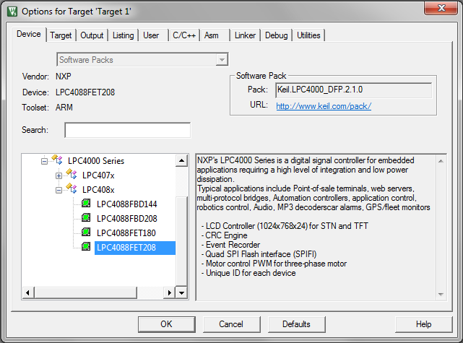
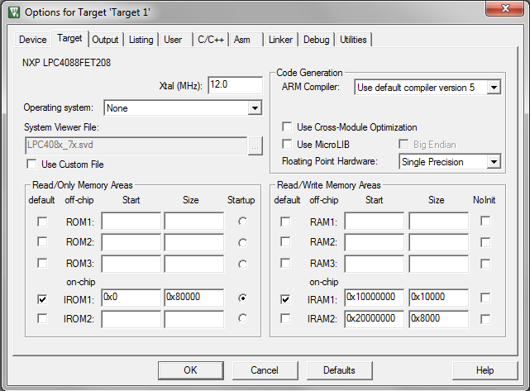
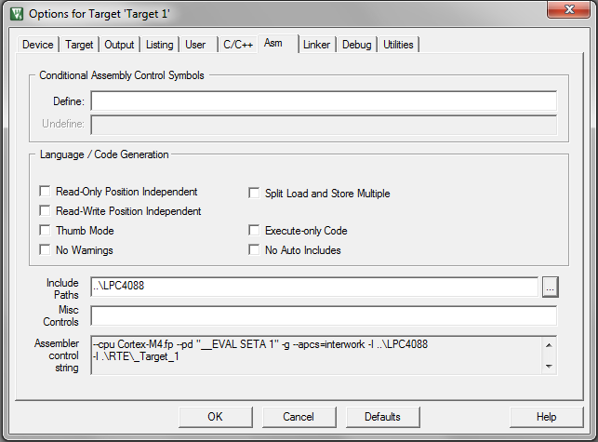
On ‘Asm’ tab, go to ‘Include Paths’ edit box and type ‘..\LPC4088’. It is important!
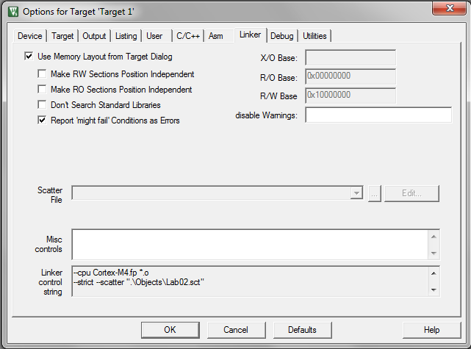
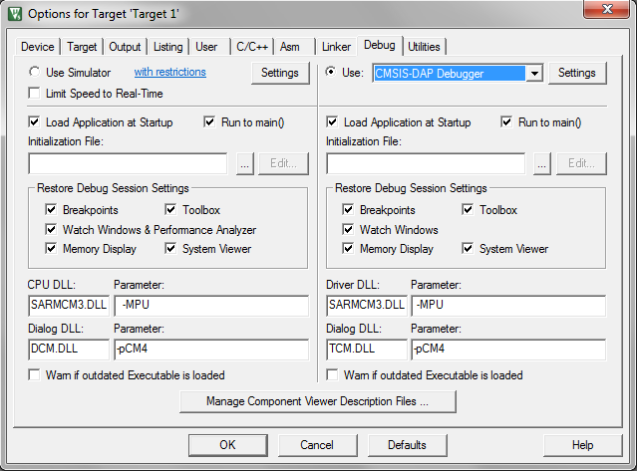
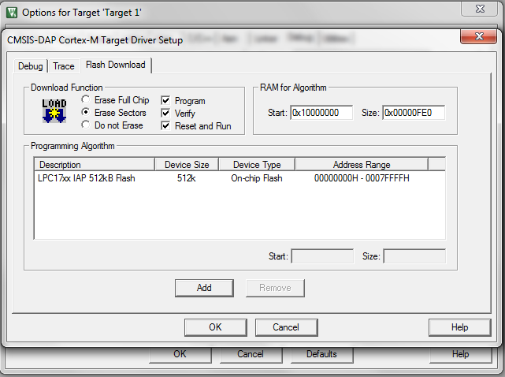

Part A
In part A you will write four subroutines and test it.
2. Add 'JoeTheStudent_Lab06_PartA.s' and 'LPC4088\startup_LPC407x_8x_177x_8x.s' files into your project. In ‘Add File’ dialog you will need to navigate to ‘..\LPC4088’ directory. Use standard ‘Up One Level’ button. Open 'JoeTheStudent_Lab05.s' file.
3. Locate the following fragment of text (second half of file):
;
; 1. In future labs you will use 'delay' procedure. The procedure may be described as:
;
; void delay(unsigned long rx)
; {
; while (rx--);
; }
;
; Write this procedure in assembler. Pass parameter throw register. rx may be any register of
; your choice.
;
delay
; -- Your code for procedure is here ---'
ALIGN

Replace '; -- Your code for procedure is here ---', line with instructions of your 'delay' subroutine.
4. When you done and your subroutine is ready to run and test, go to upper half of the file and locate the fragment:
;
; Test 'delay'
;
; vvvvvv Uncomment when procedure 'delay' is ready to test! vvvvv
; LDR R1, =5
; BL delay
; LDR R1, =0
; BL delay
; ^^^^^^^^^^^^^^^^^^^^^^^^^^^^^^^^^^^^^^^^^^^^^^^^^^^^^^^^^^^^^^^
;

5. Uncomment lines between '; vvvvvv Uncomment when... ' and '; ^^^^^^^^^^^...'. The fragment should looks like:
;
; Test 'delay'
;
; vvvvvv Uncomment when procedure 'delay' is ready to test! vvvvv
LDR R1, =5
BL delay
LDR R1, =0
BL delay
; ^^^^^^^^^^^^^^^^^^^^^^^^^^^^^^^^^^^^^^^^^^^^^^^^^^^^^^^^^^^^^^^
;

6. Set breakpoint to ' LDR R1, =5' command.

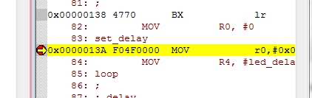

7. Use 'build target'  and 'start debug'  commands/buttons to compile, load your program. (Remember LAB01, LAB02).
Use run, step execution commands/buttons (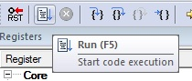 and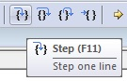) to run the program and see results. Debug your instructions if necessary.
8. Repeat steps 2 - 7 for all assignments ##2, 3 and 4. Make sure your subroutines works for all test cases.
9. Zip and submit 'JoeTheStudent_Lab06_PartA.s' file when done.
Part B
In part B you will redone Lab05_PartB with using subroutines.
The original algorithm for Lab05 is:
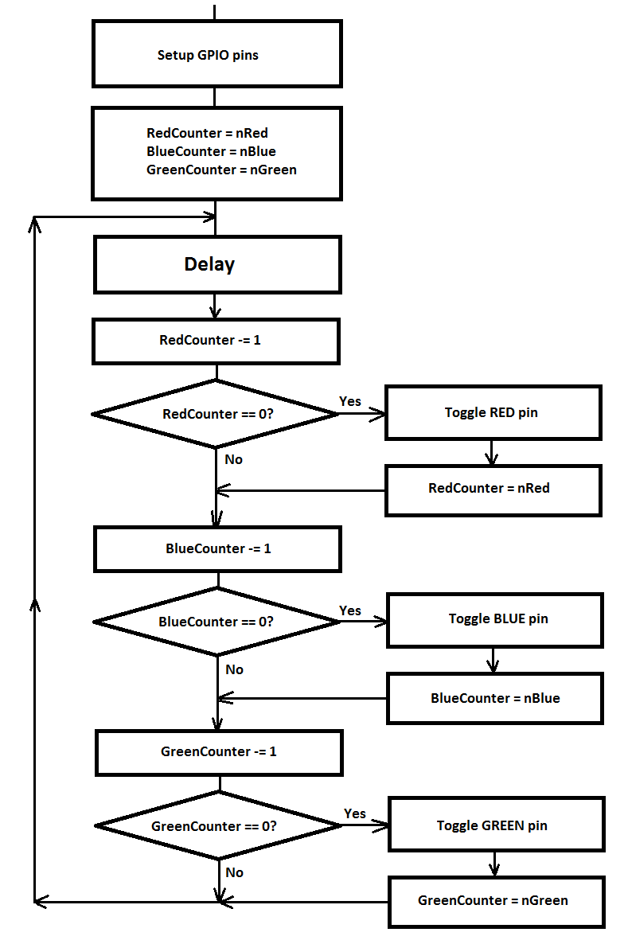
If using subroutines, It can be transformed to algorithm as following:
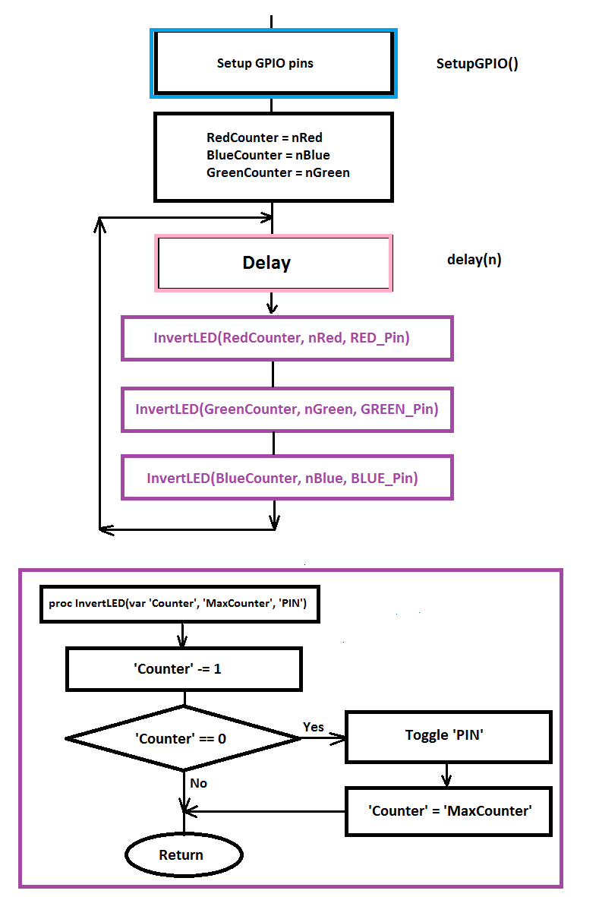

It is supposed you will make three subroutines (you may use your names for subroutines):
A. 'SetupGPIO()' (no parameters) - to setup pin functions and directions. You will need to call it from inside of 'SystemInit' subroutine. (Please remember: you have to save 'LR' before nested call as it was noted in lecture).
B. 'delay(n)' procedure - you may use the procedure you did in 'Part A' of this Lab.
C. 'InvertLED(var counter, max_counter, LedPIN)' - The algorithm is shown on the picture above. Please note, the 'counter' should be 'variable' parameter - the subroutine will change it and return new value back. All other parameters may be 'constant'. You may use GPIO port address as 'global' variable (register).
'main' program should setup proper parameters and call procedures.

